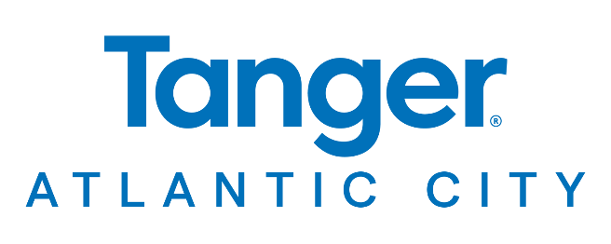

**For More Information:**

Hawley Penfold

BRAVE Public Relations

404.233.3993

[hpenfold@emailbrave.com](mailto:hpenfold@emailbrave.com)

**\*\*MEDIA ADVISORY / VISUAL AND INTERVIEW OPPORTUNITIES\*\***

**Tanger Outlets Atlantic City Offers Special Hours for Final Days of Holiday Shopping**

**ATLANTIC CITY, N.J. (Dec. 9, 2024) – Tanger Outlets Atlantic City** is offering special extended hours and daily deals to help with last-minute holiday shopping in the Atlantic County area. Top brands for gifting – such as Nike, Coach, Kate Spade and Under Armour – are stocked up and offering real savings for shoppers checking off wish lists during the final days of the season, including Super Saturday and Christmas Eve. Visitors can also take advantage of special hours on the day after Christmas for even more savings.

**WHEN:** Tuesday, Dec. 17 10 a.m. – 7 p.m.

Wednesday, Dec. 18 10 a.m. – 7 p.m.

Thursday, Dec. 19 10 a.m. – 7 p.m.

Friday, Dec. 20 10 a.m. – 8 p.m.

Saturday, Dec. 21 10 a.m. – 8 p.m.

Sunday, Dec. 22 11 a.m. – 6 p.m.

Monday, Dec. 23 10 a.m. – 7p.m.

Christmas Eve, Dec. 24 8 a.m.– 8 p.m.

Christmas Day, Dec. 25 **CLOSED**

Thursday, Dec. 26 10 a.m. – 7 p.m.

**WHERE: Tanger Atlantic City**

1931 Atlantic Avenue

Atlantic City, NJ 08401

**MEDIA**

**ACCESS:** Tanger Atlantic City is available to host media onsite, including live shots, as shoppers check off last-minute gifting needs. Please contact **Hawley Penfold** at **720. 416.1005** in advance to coordinate easy access and arrival details.

To learn more about holiday plans at Tanger Atlantic City, visit [tanger.com/Atlanticcity](http://www.tanger.com/Atlanticcity) and connect on [Facebook](https://www.facebook.com/p/Tanger-Outlets-100089842456099/) and [Instagram](https://www.instagram.com/tangeroutletsatlanticcity/).

###